**Jenkins with ansible**

Install Ubuntu 16.04 machine ,install ansible and perform ssh connection with node

Ansible plugin version :0.3

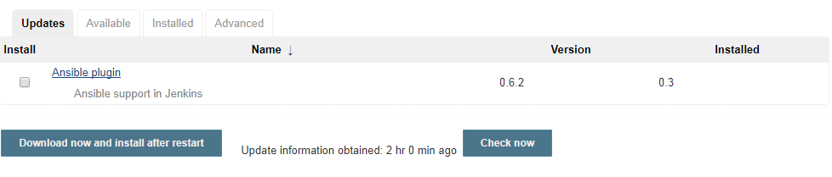

Add path to manage node

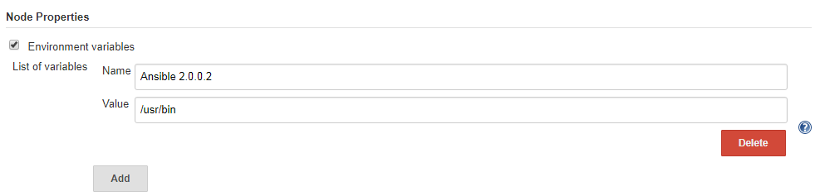

Install sshpass in Ubuntu machine-master

**apt install sshpass**

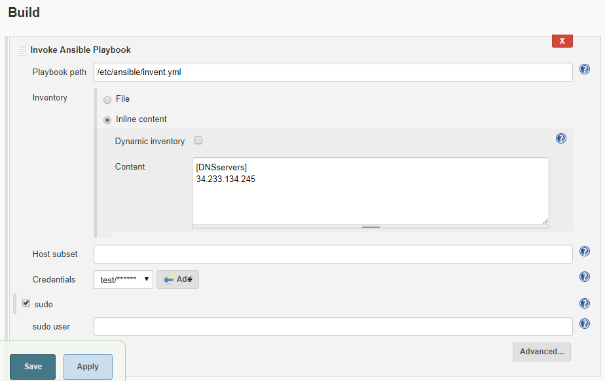

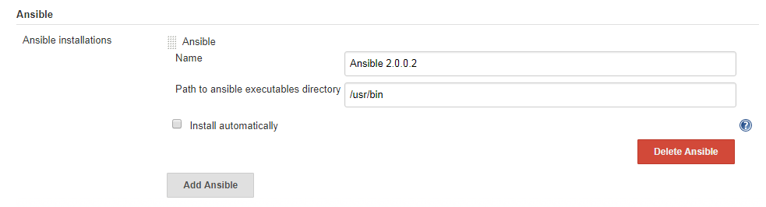

Output

